**Extreme Heat or Heatwaves in the UK**

For the weather to constitute a heatwave, it has to be unusually hot for a sustained period of time.

When do we get heatwaves in the UK? Tropical continental air can bring warm, sunny weather but it is anticyclones, high pressure systems, that give us heatwaves. In an anticyclone, the air is sinking – as it sinks, the pressure of the air rises and it gets warmer so any cloud droplets evaporate leading to clear skies. In the summer, this means that the Sun’s light warms the ground which in turn warms the air above. Anticyclones tend to last a relatively long time – maybe several weeks, so the ground and therefore the air above it can really heat up. Without any clouds, there is very little chance of any rainfall.

A UK heatwave is deﬁned by the Met Ofﬁce as a period of at least three days when the temperature is higher than the regional temperature threshold. If Summer temperatures are usually quite high in a place, it has to get even hotter to count as a heatwave.So, if you are based in a region in the South of the UK, the average summer temperature where you live is higher than the Scottish Highlands and the threshold for a heatwave is higher too.

This map shows the heatwave threshold in the UK – note the regional differences with the threshold being 28°C around London but only 25°C for Scotland and much of Wales, northern England and the southwest:

As the climate warms, all weather types can still occur, but extremely cold weather happens less frequently and extremely warm weather happens more frequently. Weather that was unusually warm before, becomes normal or more likely. All the ten hottest UK temperatures ever recorded have happened in the years since 2003.

#### So, the Met Ofﬁce has had to change its deﬁnition of what counts as a heatwave – if a heatwave is if the temperature is warmer than normal for that place, if ‘normal’ changes, so does the definition of a heatwave.

This map shows the heatwave threshold from 1961-1990 with the same colour key as the previous map – you’ll notice it’s quite different.

The hot weather that we experience during a heatwave can lead to serious health issues for people (and plants and animals). It’s heatstroke that poses a risk to health during a heatwave. Normally, we sweat to keep cool. During especially hot weather, our bodies may not be able to keep cool enough by sweating. This means our body temperature rises, which can lead to headaches, dizziness, and, in extreme cases, even death.

Dehydration is another risk of heatwaves. It can cause problems with breathing or heart rate. People who are elderly or already ill are especially vulnerable.

#### It’s actually the temperatures at night that have the biggest impacts on our health – if you can’t cool down overnight, you’re more likely to become ill.

Heatwaves are usually associated with lower levels of rainfall. Very dry conditions mean that moorland and forest ﬁres are more likely to break out. People are more likely to be outside, maybe having barbeques during hot weather, which can lead to sparks setting dry grass and vegetation alight. Many vulnerable areas now ban things like barbeques, but cigarettes and cars can still pose risks.

In 2018, a wildﬁre on Saddleworth Moor in Greater Manchester blazed for more than three weeks, due to the hot, dry weather conditions. At its peak, the ﬁre covered an area of seven square miles and a hundred soldiers were drafted in to help ﬁreﬁghters.

In 2022, the UK experienced three short heatwaves. In mid-July, some parts of the UK saw temperatures reach over 40°C for the ﬁrst time in recorded history. The highest temperature recorded was 40.3°C in Coningsby, Lincolnshire. This was a huge 1.6°C above the previous highest recorded temperature for the UK - a record set in 2019. Scotland also had its highest temperature with 34.8 °C recorded at Charterhall.

High pressure area

This weather chart is for 17th July during the heat wave. You’ll see the large area of High pressure over the south of England (with a centre marked by an H and largesly enclosed by the 1024mbar contour). There’s a depression, a storm, to the North of Scotland, with low pressure (L) marked in its centre and a warm front to the east of Scotland and a cold front to the west, but that wouldn’t affect most of the country. The High pressure are will have clear skies, and very light southerly winds as the air blows clockwise around the centre of the High.

Temperatures were between 2 and 4°C warmer than they would have been without global warming – the event would have been impossible in a pre-industrial climate.

The Met Ofﬁce issues Extreme Heat Warnings as part of the weather forecast so that people can be prepared, take precautions, and keep an eye out for vulnerable people.

A red warning was issued well in advance of the July heatwave, which was then declared a national emergency to allow various safety measures to be put into place. With these temperatures illness and death can occur among the fit and healthy – not just in high-risk groups.

On this map which shows the area affected by the heat warning, you can see the impact the sea has – as water heats up and cools down more slowly than land, in hot periods the air near water tends to be cooler, and you can also see the effect of hills – the Pennines kept the area between Manchester and York cooler.

Rail travel was suspended and some roads and airports closed as the tarmac melted. Some places had to stop selling chocolate because it was melting on the shelves and in delivery vehicles.

A number of schools announced they would either close or allow pupils to wear PE kit instead of school uniform.

England experienced its driest July since 1935, and in the South-East and Central Southern England it was the driest July since records began in 1836. There were almost 25,000 wildfires across the country and houses were destroyed in places including Nottinghamshire, Kent, Norfolk and South Yorkshire. The London fire brigade had its busiest day since World War two.

There were impacts for water supply with some regions announcing hosepipe bans. As well as the lack of rainfall, people tend to use more water during heatwaves to water gardens and fill paddling pools.

There are also implications for electricity use – with more people running fans and air conditioning. **Air conditioning** is actually quite a tricky issue – it might cool the air inside a building or car down, but it warms the air outside up, making the local problem even worse. Also, air conditioning units use hydrofluorocarbons, which are themselves a potent greenhouse gas.

In England and Wales, around 4500 deaths can be attributed to the 2022 heatwave.

By 2100, the UK could see 40°C every three to four years unless we as a global community take very rapid action to limit the amount of greenhouse gases in the atmosphere. In urban areas, nature based solutions such as planting trees, as well as creating water features and changing the colour and materials used in urban infrastructure can really reduce the impact of heatwaves.

The Heatwave Plan for England aims to prepare for, alert people to, and prevent, the major avoidable effects on health during periods of severe heat in England.

It recommends a series of steps to reduce the risks to health from prolonged exposure to severe heat for:

• the NHS, local authorities, social care, and other public agencies

• professionals working with people at risk

• individuals, local communities and voluntary groups.

**Urban Heat Islands**

An urban heat island (UHI) is a metropolitan area which is significantly warmer than its surrounding rural areas. Urban heat islands can significantly compound extreme heat events. The temperature difference is usually larger at night than during the day and is most obvious when winds are weak. One of the main causes of the urban heat island is the fact that there is little bare earth and vegetation in urban areas. This means that less energy is used up evaporating water, that less of the Sun’s energy is reflected and that more heat is stored by buildings and the ground in urban than in rural areas. The heat generated by heating, cooling, transport and other energy uses also contributes, particularly in winter, as does the complex three-dimensional structure of the urban landscape.

Water is constantly being lost from bare earth (evaporation) and from all sorts of vegetation (evapotranspiration). This moves energy (heat) from the surface of the ground up into the atmosphere.

In big towns and cities, there is less bare earth and vegetation than in rural areas.

In rural areas, there tend to be more lakes, ponds, streams and rivers than in urban areas. Also, when it rains, water tends to be quickly channelled into underground drains and sewers and is not left on the urban surface to cool it down.

The lighter or shinier a surface, the more of the Sun’s energy gets reflected straight back out to space, without heating up the ground.

Many urban surfaces are very dark – tarmac, roofs etc. so more of the Sun’s energy tends to get reflected in rural areas – although it depends a lot on what sort of rural environment you are looking at. Sand and water are much more reflective than thick woodland. Albedo is measured on a scale of 0 (nothing reflected) to 1 (everything reflected). Any of the Sun’s energy that isn’t reflected back into space is absorbed, heating the object up. So, the lower the albedo, the hotter the object will get.

A daytime infrared image of a street in Melbourne, Australia

To make matters worse, many buildings are designed to store heat – insulation etc. means that, once they warm up, it’s very hard to cool them down at night.

This means that rural areas cool down faster than urban areas at night.

Also, vehicles, heating systems, air conditioning etc. all release extra heat into the urban environment.

The complex three-dimensional structure of the urban landscape means that they are less well ventilated than rural areas. Heat (and pollution) can literally get trapped in streets.

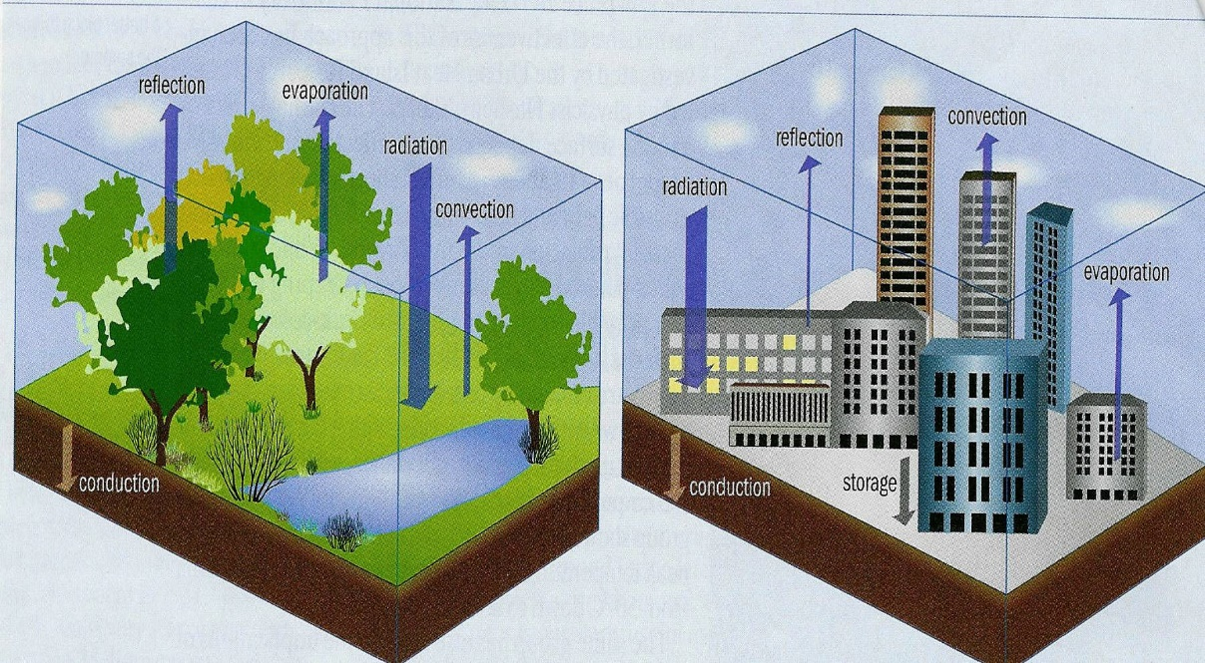

From <http://www.sustainablecitiesnet.com/2010/09/08/urban-heat-island-effect-research-collaboration/>

Towns and cities don’t heat up the same amount everywhere. The more densely built up an area is, the more it heats up. **Astroturf** is one of the surface materials with the greatest potential to generate an urban heat island.

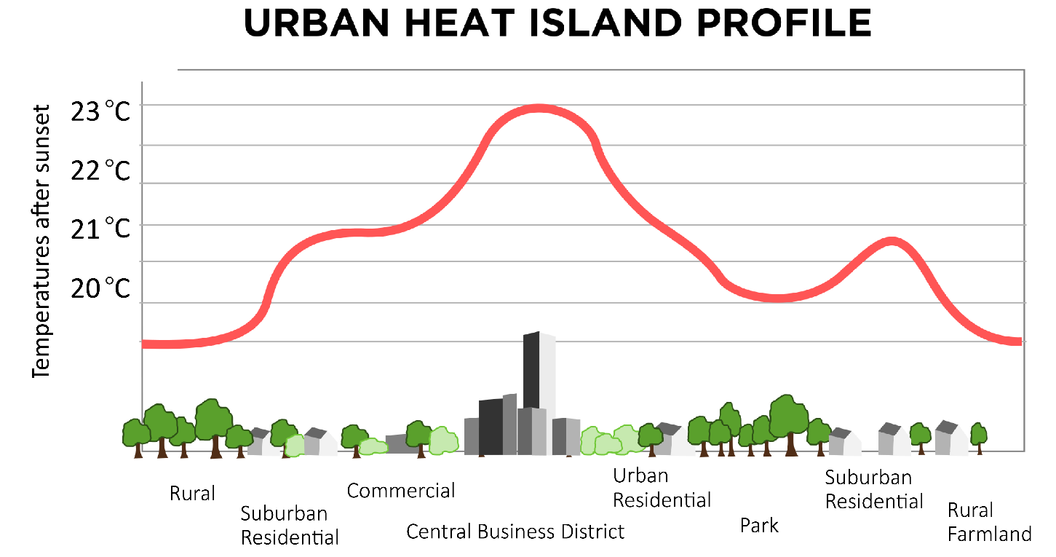

A graph showing the variation in air temperature across an urban area

Fine scale features can be very important – a small local park can reduce the local temperatures by a couple of degrees.

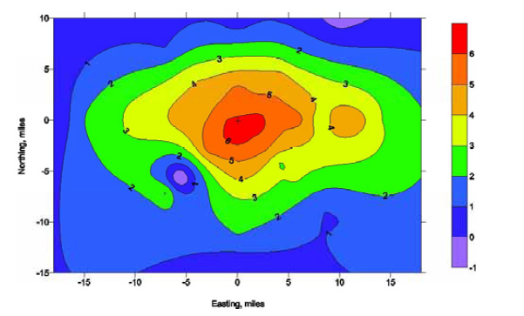

British Museum

Richmond Park

A temperature map of London on one night in 2000, showing the temperature anomaly (in °C) due to the urban heat island. Mayor of London, 2006

The Urban Heat Island dissipates rapidly at sunrise and develops rapidly at sunset. It’s the rate of cooling after sunset that sets up the UHI as well as the rate of heating after sunrise.

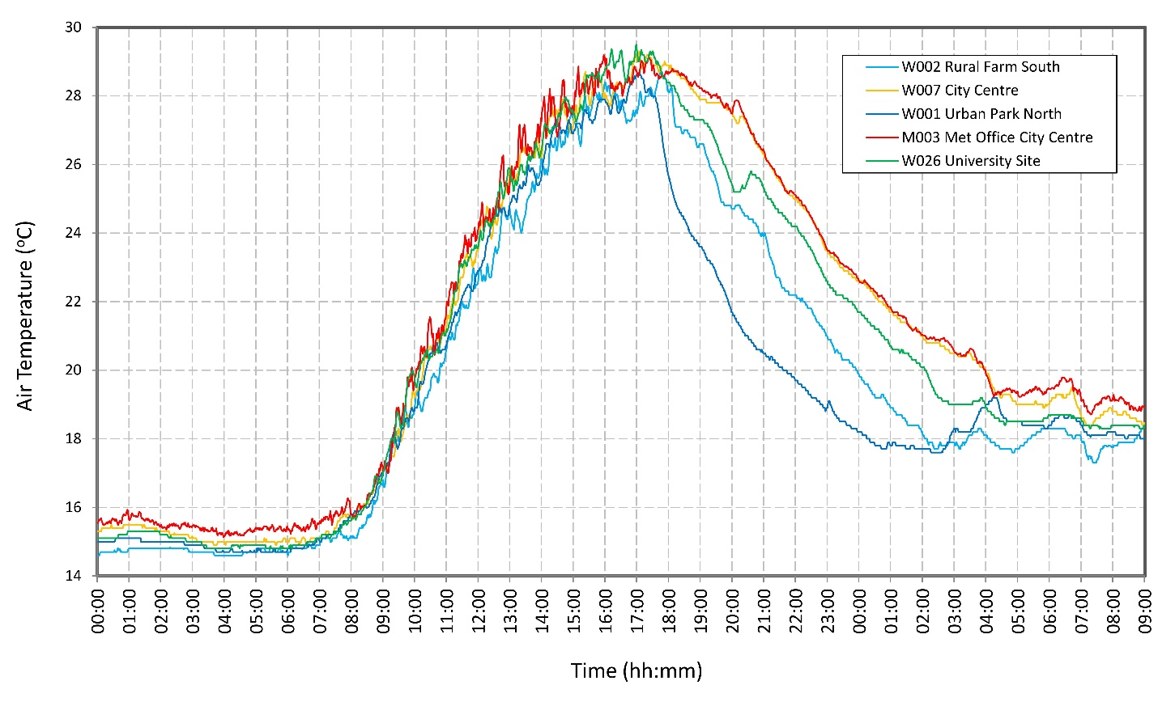The Development of Birmingham’s UHI on the night of the 22nd July 2013, during a heat wave.

NASA researchers studying urban landscapes have found that the intensity of the "heat island" created by a city depends on the ecosystem it replaced and on the regional climate. Urban areas developed in arid and semi-arid regions show far less heating compared with the surrounding countryside than cities built amid forested and temperate climates.

So, the urban heat island effect is biggest:

* In a large urban area;
* At night (before sunrise);
* In the summer;
* When there is no wind;
* When the sky is clear;
* When the weather doesn’t change through the night;
* In a city which replaces forest in a temperate climate.

**Urban Planning for Better Climate**

City planners can use computer models to see how the air flows and to help plan future developments. Many city authorities are now investigating or implementing devices to improve the urban microclimate:

**Cool surfaces** – paint buildings and pavements light, shiny colours so that they reflect light and emit infra-red radiation (heat). The paint combines a reflective basecoat with a darker pigment and could reduce air conditioning use by over 30% and cool cities by 2°C. However, they do have to be kept clean.

Similarly, cool pavements and roads reduce the heat island effect whilst also reducing storm-water runoff, giving lower tyre noise and better night-time visibility.

**Green roofs** - On a hot summer day, the surface of a green, living, roof can be cooler than the air temperature, while a rooftop without plants can be warmer. Green roofs can give a 70% reduction in air conditioning costs for a 1 storey building (less for taller buildings), reduce flooding, reduce air humidity, insulate in the winter, reduce air pollution, provide a habitat for wildlife and are a nice place to be. The stronger the roof, the bigger the plants which can be grown – Sedum is most commonly used.

**Plant vegetation** - Large trees on the south/ west of buildings can reduce air conditioning costs by 30%. Urban trees can provide:

* Air temperature reduction
* Reduced building energy use
* Absorption of UV
* Improved water quality
* Reduced noise
* Improved human comfort and well-being
* Increased property value
* Aesthetics
* Community cohesion.

Several cities, including Chicago, have tree planting programmes.

**Water features** can also have a significant local impact.

**Changing Urban Climate**

Urban areas are particularly vulnerable to changes in the climate, and, as the world becomes increasingly urbanised, more and more people will become vulnerable to changes in climate and extreme weather events.  London was up to 9°C warmer than surrounding areas during the 2003 heat wave.

Heat waves like that of 2022 are expected to become more common in the future. They will happen, on average, every other summer by mid-century and if global emissions remain high, later this century that type of summer may become a relatively cool summer.

Given the long lifetimes of buildings and urban areas we need to plan urban areas now to anticipate the summer temperatures of the future.

IPCC fact sheet – climate change in urban areas: <https://www.ipcc.ch/report/ar6/wg1/downloads/factsheets/IPCC_AR6_WGI_Regional_Fact_Sheet_Urban_areas.pdf>